
Dashboard Design

Date | 28 October 2026
Team ID | Not provided
Project Name | Global Fuel Prices and Taxation Trends (2020–2026)
Maximum Marks | 5 Marks

Creating an effective dashboard involves thoughtful design to ensure that the presented information is clear, relevant, and easily understandable for the intended audience. Here are some key principles and best practices for dashboard design
The Tableau dashboard presents fuel-price and estimated taxation/subsidy measures using simulated demonstration data. It is designed to help viewers compare trends, countries, regions, quarters, and income groups without treating the displayed values as verified real-world statistics.
Creating interactive and visually appealing dashboards involves a combination of thoughtful design, effective use of visual elements, and the incorporation of interactive features. Here are some tips to help you design dashboards that are both visually appealing and engaging for users so take care of below points
- Clear and Intuitive Layout
- Use Appropriate Visualizations
- Colour and Theming
- Interactive Filters and Slicers
- Drill-Down Capabilities
- Responsive Design
- Custom Visuals and Icons
- Use of Infographics

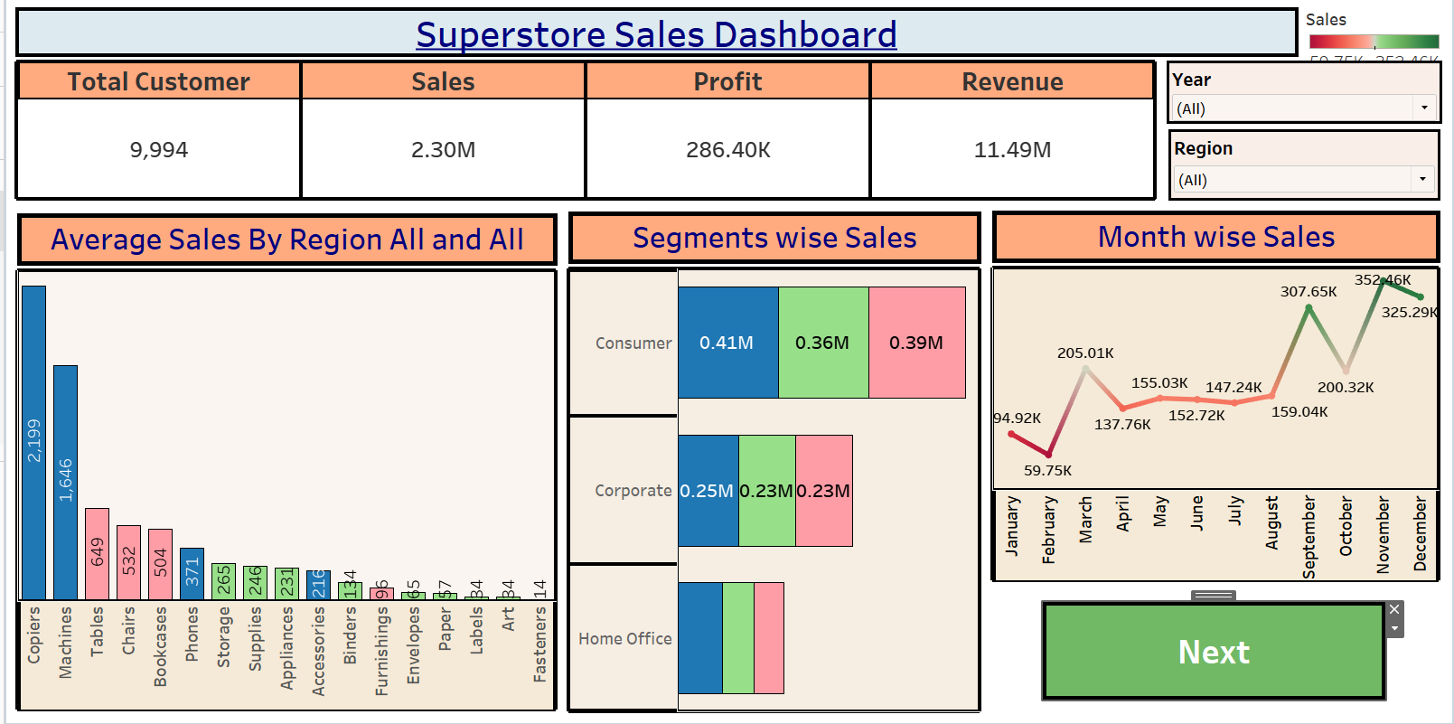
Major dashboard design outcomes
Project-specific design outcomes
Clear structure: The dashboard brings together nine views covering fuel-price trends, country ranking, quarterly patterns, regional comparisons, tax shares, subsidy shares, and income-group comparisons.
- Appropriate chart selection: Trend charts support year/quarter comparisons, ranked bars support country comparisons, and comparative views support exploration of estimated tax and subsidy measures.
- Consistent terminology: Labels distinguish fuel price (USD per litre) from estimated tax-share and subsidy-share percentages.
- Filter-led exploration: Where configured in Tableau, filters for year, quarter, country, region, fuel type, and income group allow users to narrow displayed comparisons.
- Readable presentation: Titles, axis labels, units, and legends should be clear and consistent so each metric can be understood quickly.
- Responsible interpretation: The dashboard and documentation should state that values are simulated demonstration data, not verified historical data.
Overall outcome: The dashboard demonstrates how a multi-view Tableau report can organize fuel-price and taxation-related questions into one exploratory experience.

Activity 2
Publish Dashboard on Tableau Public and Paste the Dashboard Public link below:
Example
https://public.tableau.com/views/SalesDashboard_17247660582000/Dashboard1?:language=en-US&publish=yes&:sid=&:redirect=auth&:display_count=n&:origin=viz_share_link

